Brazil, Russia, India, China and South Africa
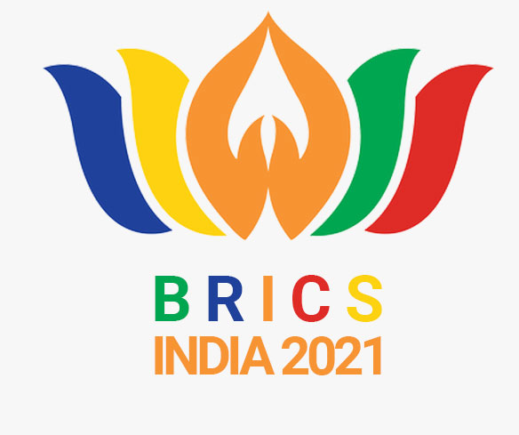

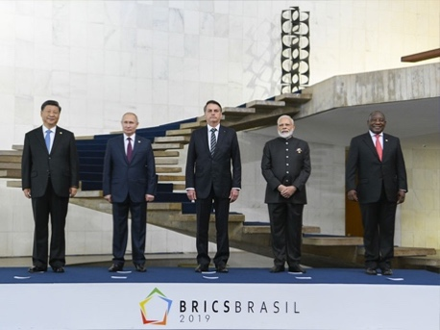 |  | 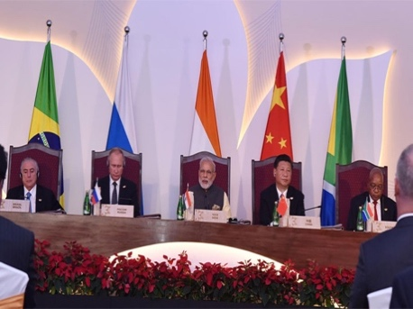
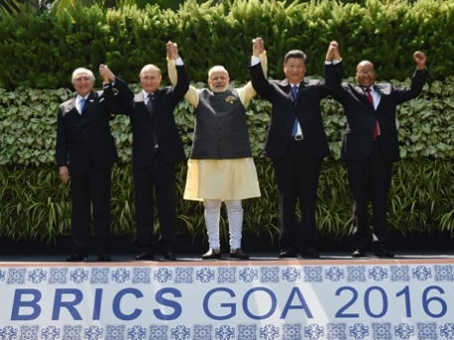 |  | 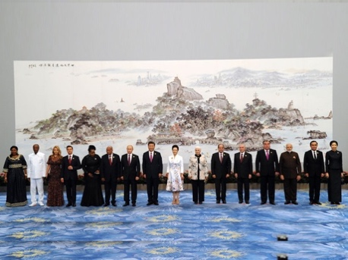

4th BRICS Young Innovator Prize Nomination Form
BRICS Young Scientists Forum (BRICS-YSF)
India Conclave, 13-16 September 2021
Building better societies through Science, Technology & Innovation

Nominee’s Photo
REQUIRED DOCUMENTS
- Nomination form;
- Nominee’s Curriculum Vitae/brief Biography;
- A photo of nominee (image must be larger than 250*300 pixels)

DEADLINE: 25 August 2021

NOMINEE’S DETAILS/INFORMATION

Country:

First Name:
Middle Name:
Last Name:

Date of Birth (Day/Month/Year):

Passport Number:
Date of Issue:
Expiry Date:

Address:

Telephone:

Email:
Title:
Gender:

Institution/Affiliation:

Field of Science and Technology:

Academic Qualification:

Nomination Statement (up to 300 words):
Please describe area of expertise in which the nominee has demonstrated innovation excellence. Please information in English.

Innovative Project Statement (up to 300 words):
Please provide brief information on the nominee’s innovative idea. Please information in English.

Participation in Innovation Competitions/Awards/Achievements:
Please list previous participation in innovation competitions and awards/achievements, if any. Please provide information in English.

DECLARATION BY THE CANDIDATE:
I hereby declare that all the information given above is true to the best of my knowledge. Further, in the event of being selected, I undertake to accept the offer to participate in the 6th BRICS Young Scientist Forum in India, and will attend the full program of three days and will not seek any personalised program during the visit.

PLACE:
DATE:

SIGNATURE OF THE NOMINEE:

NAME OF THE NOMINATING AUTHORITY
(with contact details, i.e. telephone, email and designation)

PLACE:
DATE:

SIGNATURE

NB: Remember to include the following on the Nomination Form:

- Nominee’s Curriculum Vitae/Biography
- Photo of nominee (image must be larger than 250*300 pixels)

